1.) What is Computer?

A device for processing, storing, and displaying information.

2.) What are the essential parts of computer?

**Motherboard** - the primary circuit board that holds all the hardware in place. **Central Processing Unit (CPU)** – commonly referred to as the processor - is the ‘brain’ of your computer.

**Graphics Processing Unit (GPU)** - is the computer hardware responsible for handling graphical operations and advanced imagery.

**Random Access Memory (RAM)** – device keeps important currently-used data and codes on standby, loading them instantly when respective programs or apps are opened.

**Hard Disk or Solid State Drive** - provides the memory for installing programs and saving files. Unlike RAM, a storage device’s content is secured in non-volatile memory, meaning that data is saved permanently inside its memory bank, preserving them even after you turn off the PC (unless manually deleted or uninstalled).

3.) Who are the notable inventors of hardware and software?

**5 Hardware inventors:**

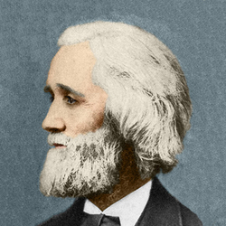**Christopher Latham Sholes** - Born February 14, 1819, near Mooresburg, Pennsylvania, U.S.—died February 17, 1890, Milwaukee, Wisconsin was an American inventor who developed the typewriter.

Figure 1 Christopher Latham Sholes

**Patty McHugh** - invented the motherboard and paved the way for future innovations. Patty McHugh’s contribution to the development of the first motherboard is still recognized today, earning her the title of Patty McHugh motherboard pioneer.

Figure 2 Patty McHugh

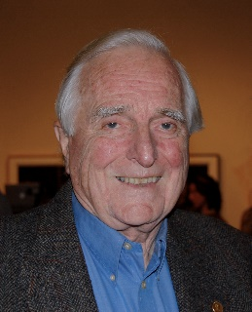**Douglas Engelbart -** (born January 30, 1925, Portland, Oregon, U.S.—died July 2, 2013, Atherton, California) was an American inventor whose work beginning in the 1950s led to his patent for the computer mouse, the development of the basic graphical user interface (GUI), and groupware.

Figure 3   
Douglas Engelbart

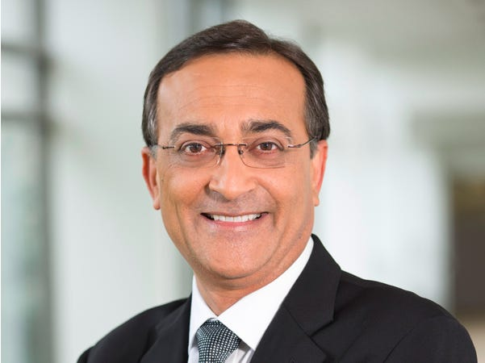

**Ajay Bhatt** - is a computer engineer who is widely recognized as one of the key inventors of the Universal Serial Bus (USB). His work has had a profound impact on the electronics industry in countless ways; including the standardization of interfaces, increased data transfer speeds, and improved power management.

Figure 4 Ajay Bhatt



**Quentin Stafford-Fraser** - is a computer scientist and entrepreneur in Cambridge, England. He goes by Quentin in his web presence, but he is listed as James Stafford-Fraser on some of his older patents. He is most well-known for his involvement in the creation of the Trojan Room coffee pot, the world's first webcam. He is the founder of several technology and computer companies, including Telemarq Ltd and DisplayLink.

Figure 5   
Quentin Stafford-Fraser

**5 Software inventors:**

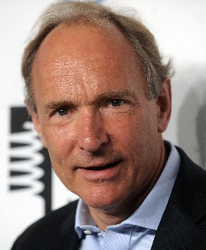**Tim Berners-Lee** - Born June 8, 1955, London, England) is a British computer scientist, generally credited as the inventor of the World Wide Web (WWW). In 2004, he was awarded a knighthood by Queen Elizabeth II of the United Kingdom and the inaugural Millennium Technology Prize (€1 million) by the Finnish Technology Award Foundation.

Figure 6 Tim Berners-Lee

**Ray Tomlinson** - a renowned computer programmer, is credited as the inventor of email on the ARPANET system, the predecessor to the Internet. He revolutionized the way businesses operate and people communicate throughout the world. Tomlinson was born in Amsterdam, New York on April 23, 1941. He earned his Bachelor of Science degree in electrical engineering from the Rensselaer Polytechnic Institute (RPI) in Troy, New York in 1963.

Figure 7 Ray Tomlinson

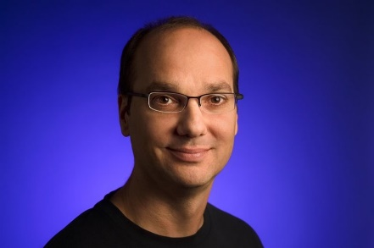**Andy Rubin** - He cofounded Android in 2003 and sold it to Google in 2005, when the smartphone industry was still a confusing morass of underwhelming and incompatible devices. By giving away Android’s OS, Rubin provided manufacturers with a common language and set of tools, igniting the smartphone boom.

Figure 8 Andy Rubin

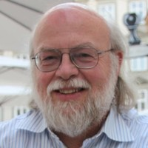**James Gosling -** Java was created at Sun Microsystems, Inc., where James Gosling led a team of researchers in an effort to create a new language that would allow consumer electronic devices to communicate with each other. Work on the language began in 1991, and before long the team’s focus changed to a new niche, the World Wide Web. Java was first released in 1995, and Java’s ability to provide interactivity and multimedia showed that it was particularly well suited for the Web.

Figure 9 James Gosling

**Bill Gates** - Born October 28, 1955, Seattle, Washington, U.S.) is an American computer programmer and entrepreneur who cofounded Microsoft Corporation, the world’s largest personal-computer software company.

Figure 10 Bill Gates

Gates wrote his first software program at the age of 13. In high school he helped form a group of programmers who computerized their school’s payroll system and founded Traf-O-Data, a company that sold traffic-counting systems to local governments. In 1975 Gates, then a sophomore at Harvard University, joined his hometown friend Paul G. Allen to develop software for the first microcomputers. They began by adapting BASIC, a popular programming language used on large computers, for use on microcomputers.

4.) Cite your References:

- Freiberger, P. A., Hemmendinger, D., Swaine, M. R., & Pottenger, W. M. (2024, July 4). Computer | Definition, History, operating systems, & Facts. Encyclopedia Britannica. <https://www.britannica.com/technology/computer>

- Vedantu. (n.d.). Parts of a computer. VEDANTU. <https://www.vedantu.com/coding-for-kids/parts-of-a-computer>

- National Inventors Month: 15 Famous computer scientists and their inventions | Turing. (n.d.-b). <https://www.turing.com/blog/famous-computer-scientists-and-their-inventions>

- Microsoft is born - Stories. (2020, December 7). Stories. <https://news.microsoft.com/announcement/microsoft-is-born/>

- Admin, C. W. (2023, July 27). Douglas Engelbart: Computer visionary. Berkeley Engineering. <https://engineering.berkeley.edu/douglas-engelbart-computer-visionary/>

- Team, W. C., & Team, W. C. (2020, March 16). The world’s first webcam was invented to watch a coffee pot. Waka Coffee & Tea. <https://www.wakacoffee.com/blogs/coffeelifeblog/worlds-first-webcam-to-watch-a-coffee-pot>

- Volle, A. (2023, April 21). Motherboard | Definition, History, & Facts. Encyclopedia Britannica. <https://www.britannica.com/technology/motherboard>

- The Editors of Encyclopaedia Britannica. (1998, July 20). Christopher Latham Sholes | QWERTY keyboard, typewriter, printer. Encyclopedia Britannica. <https://www.britannica.com/biography/Christopher-Latham-Sholes>

- Aydin, R., & Hartmans, A. (2021, March 24). The rise and fall of Andy Rubin, the former Google executive accused of sexual misconduct whose new startup, Essential, just shut down for good. Business Insider. <https://www.businessinsider.com/android-sex-ring-leader-rise-fall-google-exec-andy-rubin-2019-7>

- The Editors of Encyclopaedia Britannica. (1998, July 20). *Christopher Latham Sholes | QWERTY keyboard, typewriter, printer*. Encyclopedia Britannica. <https://www.britannica.com/biography/Christopher-Latham-Sholes>

- Class, D. (2024, August 5). History of the computer motherboard. Blogs - Digital Class. <https://www.digitalclassworld.com/blog/history-of-motherboard/#:~:text=The%20inventor%20behind%20this%20technology,of%20Patty%20McHugh%20motherboard%20pioneer>.

- Hall, M. (2024, June 28). Douglas Engelbart | Inventor of the computer mouse. Encyclopedia Britannica. <https://www.britannica.com/biography/Douglas-Engelbart>

- Ajay Bhatt and the Universal Serial Bus. (n.d.). News - SparkFun Electronics. <https://www.sparkfun.com/news/6774#:~:text=Ajay%20Bhatt%20is%20a%20computer,Universal%20Serial%20Bus%20(USB)>.

- Quentin Stafford-Fraser | Golden.

<https://golden.com/wiki/Quentin_Stafford-Fraser-W46W5V>

- Dennis, M. A. (2024, July 5). Tim Berners-Lee | Biography, Education, Internet, Contributions, & Facts. Encyclopedia Britannica. <https://www.britannica.com/biography/Tim-Berners-Lee>

- Ray Tomlinson | Lemelson. (n.d.). <https://lemelson.mit.edu/resources/ray-tomlinson>

- Tanz, J. (2016, February 9). Andy Rubin unleashed Android on the world. Now watch him do the same with AI. WIRED.

<https://www.wired.com/2016/02/android-inventor-andy-rubin-playground-artificial-intelligence/#:~:text=He%20cofounded%20Android%20in%202003,tools%2C%20igniting%20the%20smartphone%20boom>.

- The Editors of Encyclopaedia Britannica. (2024, July 21). Java | Definition & Facts. Encyclopedia Britannica. <https://www.britannica.com/technology/Java-computer-programming-language>

- Britannica money. (2024, August 6). <https://www.britannica.com/money/Bill-Gates>